Module Assembly - TopCoder NodeJS Authentication Middleware v1.0 Deployment Guide

Revision History
Author | Revision Number | Date
TCSASSEMBLER | 1.0 | 2014/01/15

Deployment Instructions 3
1. Organization of Submission 3
2. Application Setup 3
2.1. Preconditions 3
2.2. Build Script Setup 3
2.3. Database setup 5
3. Configurations 5
4. Deployment Instructions 6
5. Verification by tests 7
6. Manual verification 8
7. Manual verification with real jwt 9
8. Resource Contact List 12

Deployment Instructions

Organization of Submission
Name | Description
tc-api/ | Main application source code of this assembly.  Contains only changed files.
Module Assembly - TopCoder NodeJS Authentication Middleware v1.0.doc | This file.
sample-app/ | Code of sample application that generate real JWT token.

Application Setup

Preconditions
- Linux 64bit System (preferably the Ubuntu 10.04), which is used by Heroku stack for Nodejs), with development tool, such as g++, maker.
- Java (used to connect remote Informix Server)
- NodeJS 0.10.21 http://nodejs.org/
- Node-java https://github.com/joeferner/node-java
- Git
- Heroku Account and Toolbelt
  - Signup a Heroku account in https://api.heroku.com/signup/devcenter with your email address.
  - Download the Heroku Toolbelt from https://toolbelt.heroku.com, and make sure the Heroku CLI is working in your environment by typing the “heroku help”.
  - Login your Heroku account by typing the “heroku login”.
This requires you to input your email and password, and then finally it will upload your public SSH key to the server so that you don’t have to provide your credential during the subsequent commands.
If you have a “Permission denied (publickey)” error during deployment, you can use “heroku keys:add” to add the public key to the remote repo as described here.

Build Script Setup
Two BASH scripts are used to ease the deployment.
- deploy/development.sh
It helps to launch the application locally.
It simply exports the configured environment variables.
- deploy/heroku.sh
It helps to deploy the application onto the Heroku cloud.
It has command line switches.
Switch | Description
clean | It cleans the current repository information by simply removing the .git folder.
commit | It initializes the local repository and commits all the current project files, if the current directory is not a GIT repo yet; or commit all the changes to the local repository, if the current directory is already a GIT repo.
create | It creates a Heroku app for the current logged-in Heroku account.  This app will only be used if it is created when the current local GIT repo has not yet setup the remote repo of name “heroku”.  If your local repo has already setup “heroku” remote for an existing app, this app will not be picked as the target app for other Heroku commands. If you want to create an new Heroku app and use it as the target app in this case, you can clean and re-initialize the current local repo first, or you explicitly rebase it to the new Heroku app.
config | It exports all the configured environment variables to the target Heroku app.
push | It pushes the current committed version to the “heroku” remote.
launch | It launches one Heroku dyno to run the target app.
all | It will execute all other steps in the order: “clean”, “commit”, “create”, “config”, “push”, and then “launch”.
deploy | It only executes the steps to deploy the projects to the Heroku cloud: “config”, “push”, and then “launch”.  It assumes the code has been committed to the local repo, and the local repo has setup the “heroku” remote for the target app.

Database setup
- Upload the submission to /mnt/shared/temp_files/
- Login vm as ‘tc’ account
- cd /mnt/shared/temp_files
- unzip submission.zip
- su informix -l
- cd /mnt/shared/temp_files/submission/tc-api/db_scripts
- dbaccess - <SCRIPT_NAME>
Where SCRIPT_NAME can be
Script name | description
oauth_fix_social_tables.sql | Create required tables. Required to run.
oauth_sample_data.insert.sql | Insert test users and their social logins.
oauth_sample_data.delete.sql | Delete test data created by oauth_sample_data.insert.sql
Database setup is required only for manual verification. (but oauth_fix_social_tables.sql is always required)
It could be possible than your VM has proper schema

Configurations
There are two BASH scripts used to ease the deployments and launching of the application.
The configurations are defined in these scripts to export the environment variables.
One of them is for local development “tcapi/deploy/development.sh”, where configurations are defined from
Please replace TC_DB_HOST and TC_DW_HOST with your VM IP
Heroku.sh doesn’t contain configuration no more.

export TC_DB_HOST=50.17.156.219
export TC_DB_PORT=2021
export TC_DB_USER=informix
export TC_DB_PASSWORD=1nf0rm1x
export TC_API_HOST=api.topcoder.com

export TC_DW_NAME=informixoltp_tcp
export TC_DW_HOST=50.17.156.219

Deployment Instructions

- Setup heroku in section 2.1 and database in section 2.3.
- Run git clone git@github.com:cloudspokes/tc-api.git tc-api
- Run cd tc-api
- Run git checkout 6a5bcacdf8371236290f8b25dd5d04d308cbf338
- Copy all files from submission/tc-api to checked out tc-api and override all files
- Replace db_host in section 3.
- In checked out tc-api run:
  - chmod +x deploy/heroku.sh
  - npm install (there is one new module)
  - . deploy/heroku.sh all
  - After running the script, you can use “git remote -v” to see the “heroku” remote repo. The remote repo will be like git@heroku.com:<app-name>.git, you can know the create app name here.
- To deploy application in local environment run:
  - chmod +x deploy/development.sh
  - npm install (there is one new module)
  - . deploy/development.sh
  - npm start
  - Server is listening on port 8080.
  - If you can’t stop application then run “. kill.sh”
  - If you get some error then try to rebuild node modules by running npm rebuild. If you have still problems then please see https://github.com/joeferner/node-java in “Installation Linux/Windows notes”. Make sure you have installed java.

Verification by tests
  - Js lint
Install the node-jslint in your local environment globally by “sudo npm install jslint -g".
Run following command under the <submission>/tc-api directory. It will check only new or updated files in this contest.

find . -name "*.js" -print0 | xargs -0 jslint -nomen

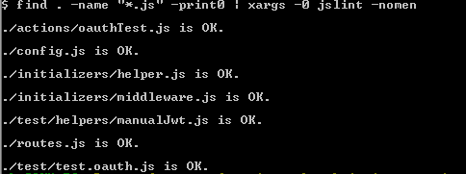

  - Mocha
Deploy application to localhost. See 4.8.
Run following commands under the <base>/tc-api directory.
(Run again “. deploy/development.sh” if you get invalid port error)

mocha test/test.oauth.js
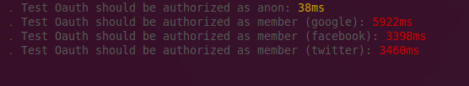
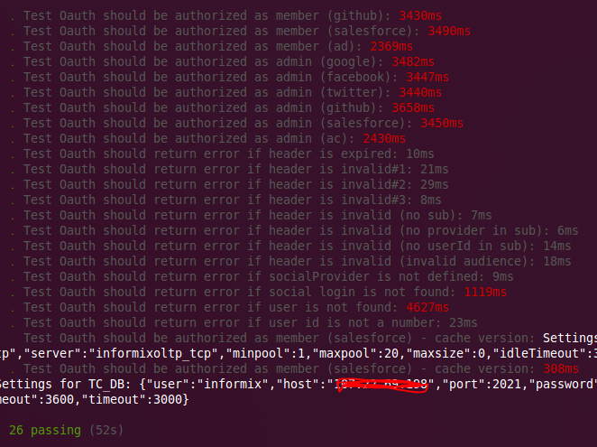

Manual verification
To test application in heroku replace in below URLs localhost:8080 by <your-app>.herokuapp.com

Run oauth_sample_data.insert.sql from section 2.3.

We must generate jwt token first.
Run node node test/helpers/manualJwt.js "facebook|fb1234"
Token should be logged to the console. Copy it and run below command.
Replace TOKEN_HERE to your token

curl \
-H 'Authorization: Bearer TOKEN_HERE' \
http://localhost:8080/test/oauth

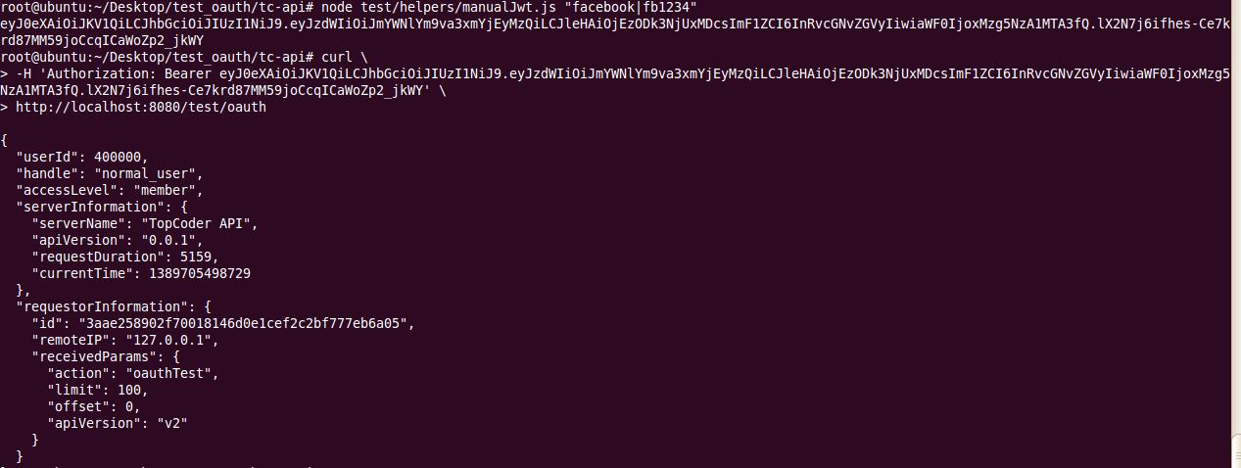

This sample method just ouputs connection.caller to the response.

Run request with invalid token:

curl \
-H 'Authorization: Bearer xxxyy' \
http://localhost:8080/test/oauth

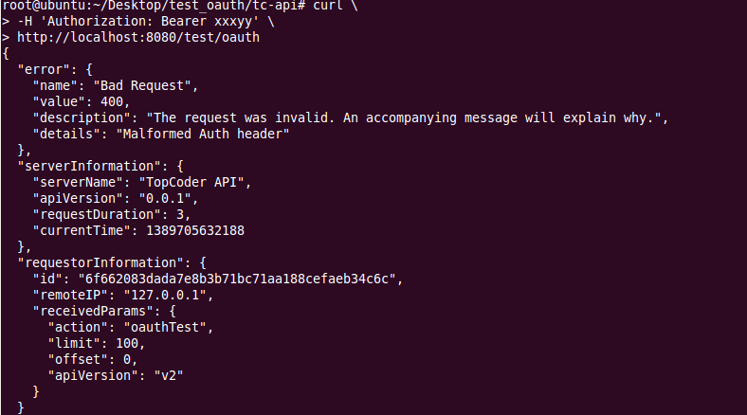

You can refer to unit tests for more cases.

Manual verification with real jwt
  - Create account in http://www.auth0.com/
  - You will have to your choose domain name. Please remember that choice.
  - Open https://app.auth0.com/#/connections/social Set Google/Gmail to ON
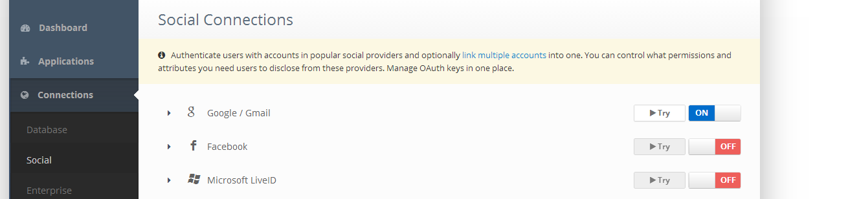

  - We need to know your social_id.
    - Click Try in above screen
    - Grant permissions
    - 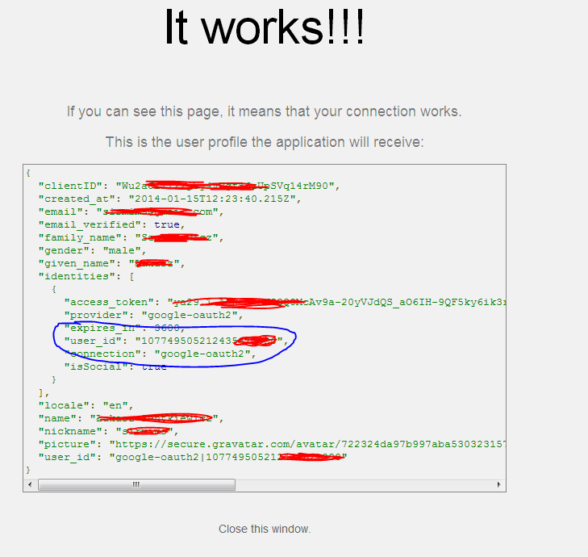
    - Copy user_id from selected area in above sreen
  - Add social login to database
    - Open oauth_sample_data.insert.sql
    - Edit line 10:
INSERT INTO user_social_login(social_user_id, user_id, social_login_provider_id, social_user_name) VALUES ('gg1234', 400000, 2, 'user1');
    - Replace gg1234 by your user_id
    - Save script and run it on VM. See section 2.3 for details.
    - Your google account is now associated with user normal_user (id 400000)
  - Open https://app.auth0.com/#/applications/create to create new applicaiton
  - Choose OpenId Connect (OAuuth2) Web
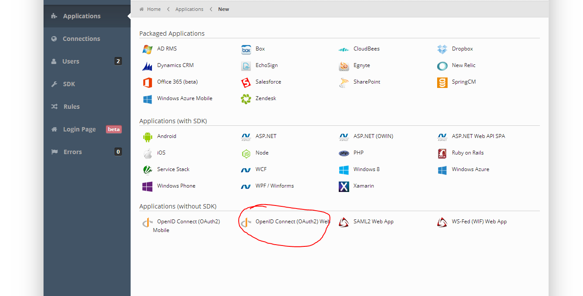
  - Pick some name and make sure Social Google is set to On
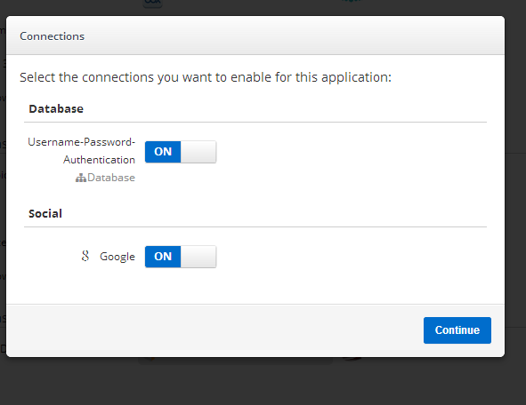
  - Go to the settings of created application
    - Set callback URL to http://localhost:12345/ and click Save Changes
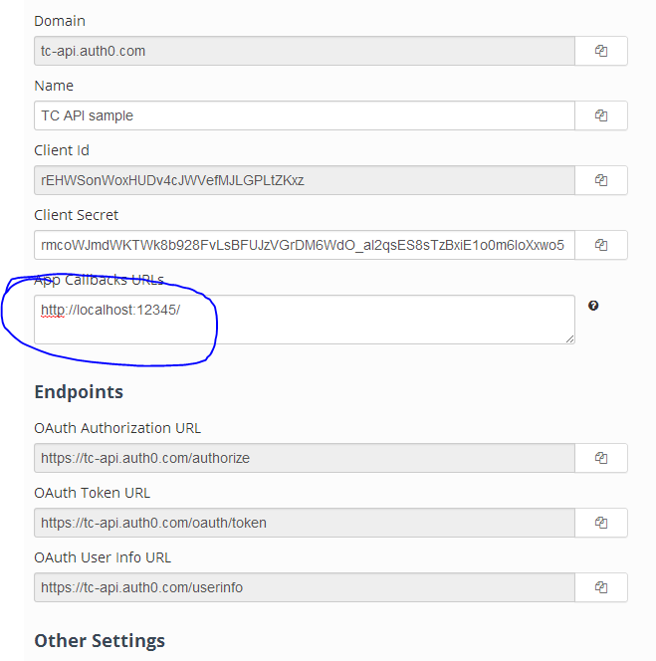
    - Edit deploy/development.sh
    - Add to the end of this file:
export OAUTH_CLIENT_ID=<CLIENT_ID>
export OAUTH_CLIENT_SECRET=<CLIENT_SECRET>
    - Replace client_id and client_secret by your application settings
    - Run . deploy/development.sh and restart the application. See section 4
  - Setup sample app
    - Edit sample-app/setup-passport.js and set you application settings
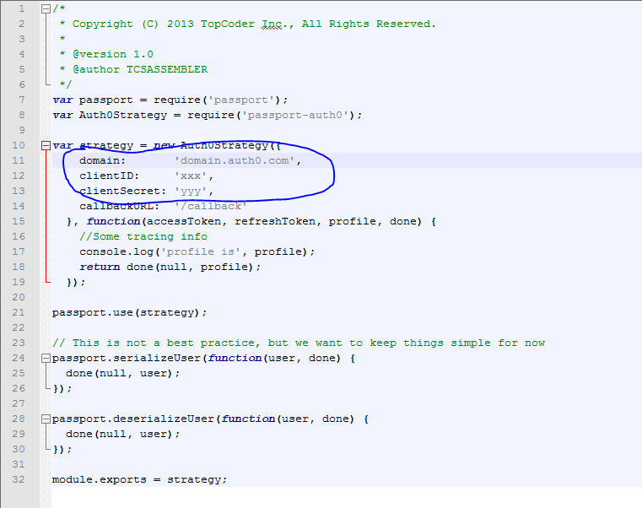
    - Open sample-app/views/test.html and update settings also.
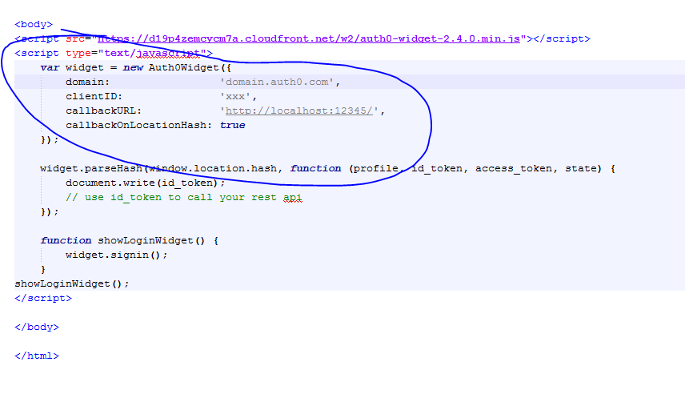
    - Run npm install
    - Run node app
    - Open http://localhost:12345/
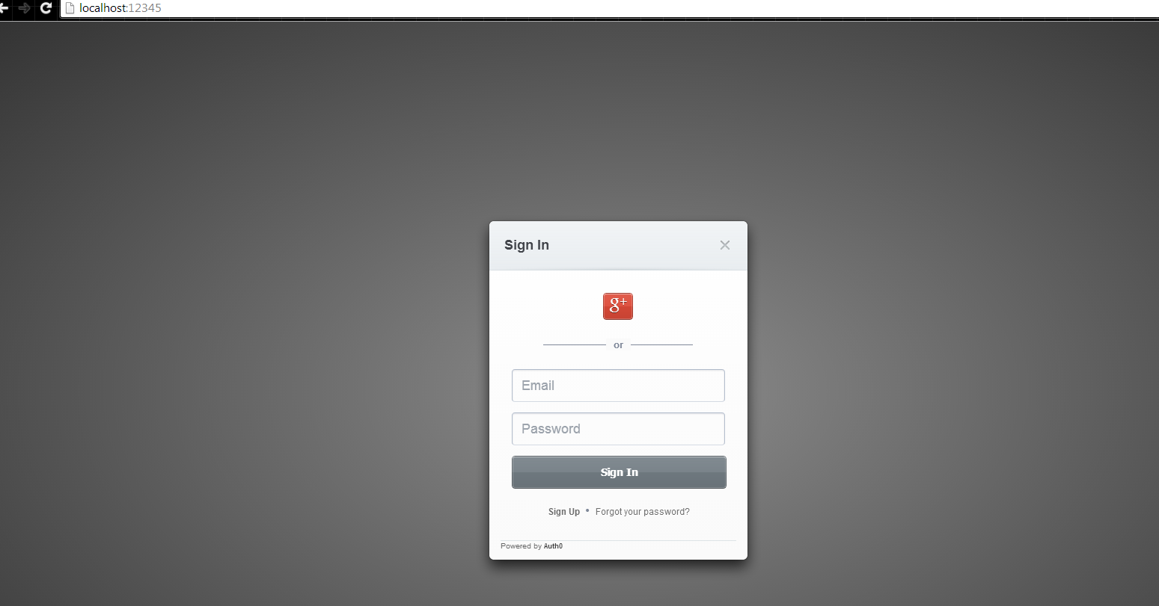
    - Click G+ icon to login
    - You should see JWT token now
  - Create request with JWT
Run below command. Replace TOKEN_HERE by your token
curl \
-H 'Authorization: Bearer TOKEN_HERE' \
http://localhost:8080/test/oauth

You should see this response
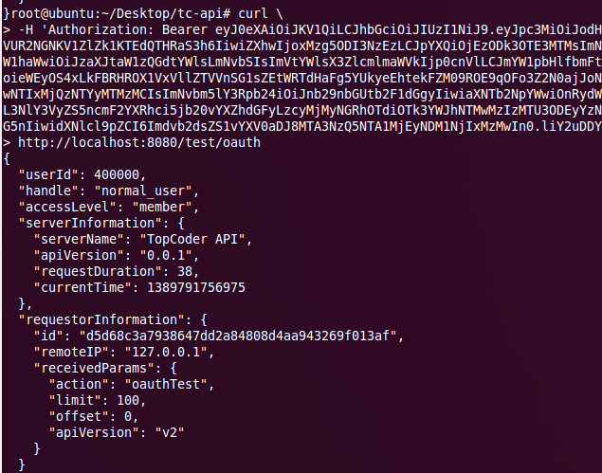

Resource Contact List
Name | Resource Email

